**Experiment No. 10-A**

**Title:**

Write a Python Program to remove punctuations from a string

**Tool/Platform:**

Microsoft Word / PowerPoint and Python IDLE

**Flowchart:**

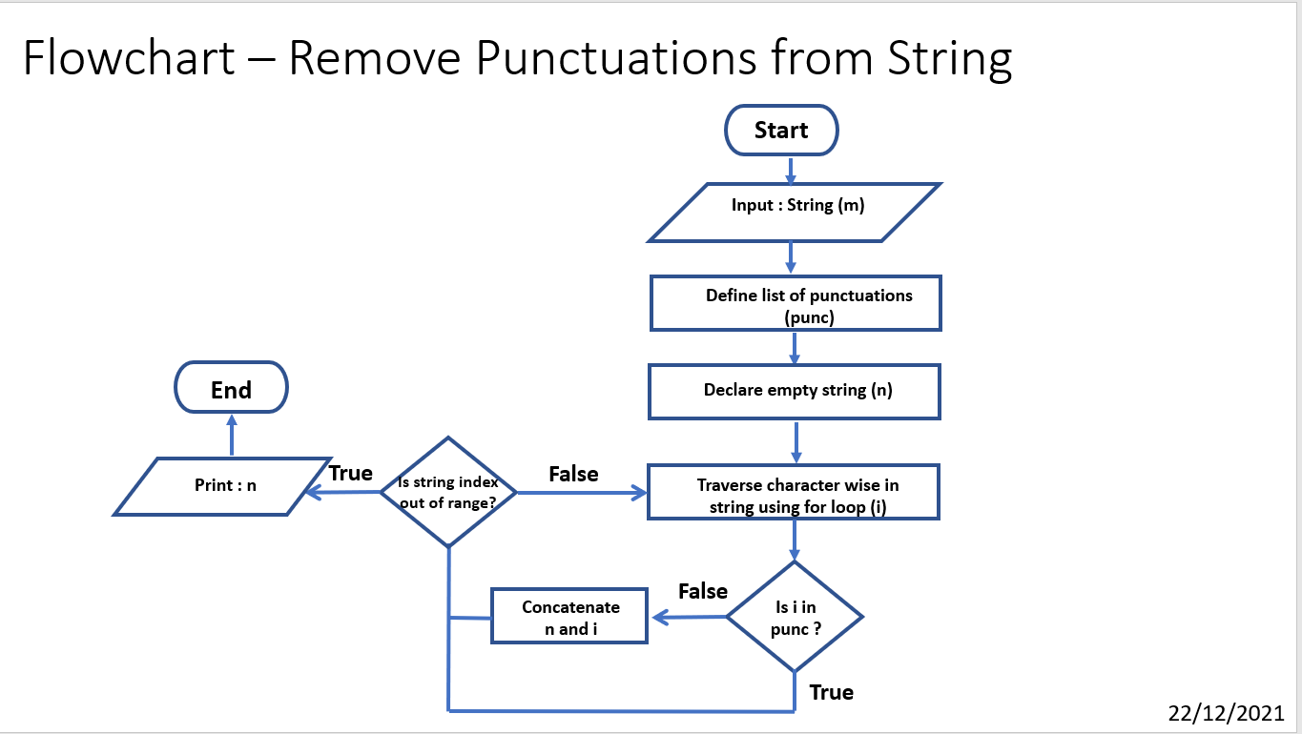

**Algorithm:**

1. Initialise the program
2. Declare a list of punctuations marks as “**punc**”
3. Input string from user and assign to “**m**”
4. Initialise an empty string “**n**”
5. Using for loop iterate “**i**” through the string “**m**” assigning it each character of the string at a time in each iteration
6. Check if the current value of “**i**” matches any element in the list “**punc**”
7. If false, concatenate that value of “**i**” with existing value of “**n**”
8. Else, omit the value of “**i**” and move on to next iteration
9. Print the value of “**n**” as filtered string
10. End the program

**Source Code:**

#remove punctuations

#Date: 22/12/2021

punc = [ '.', ",", "?", "!", "-", "_", ' \ ', "|", ";", ":", " ' ", " (" , ")" , "...", "/"]

m = input("Enter String: ")

print()

n = ""

for i in m:

if i not in punc:

n += i

print("Entered String is: \n", m)

print()

print("String after Punctuation Filter is: \n", n)

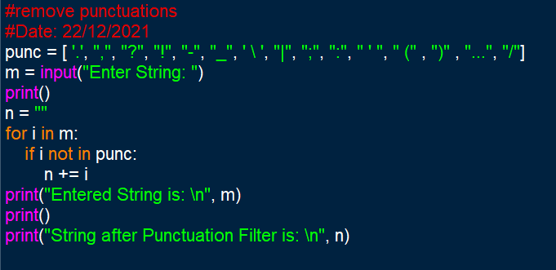

**Output Screenshots:**

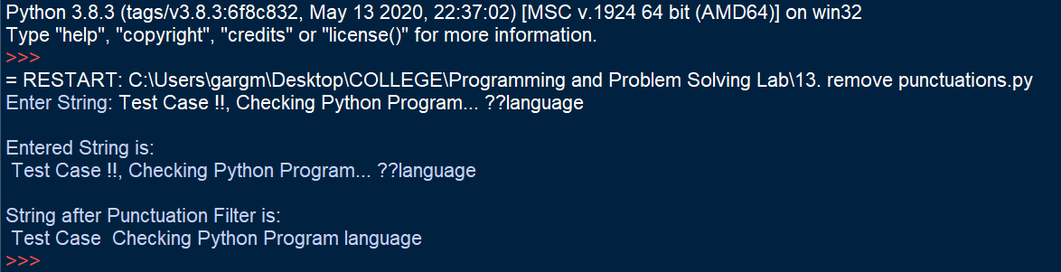

**Learning Outcome:**

The following program helped in understanding the use of lists and string. It helped to understand how for loop can be used to traverse through a string. The use and function of membership operators was understood.

**Experiment No. 13**

**Title:**

Write a Python Program to find Fibonacci Series using modules

**Tool/Platform:**

Microsoft Word / PowerPoint and Python IDLE

**Flowchart:**

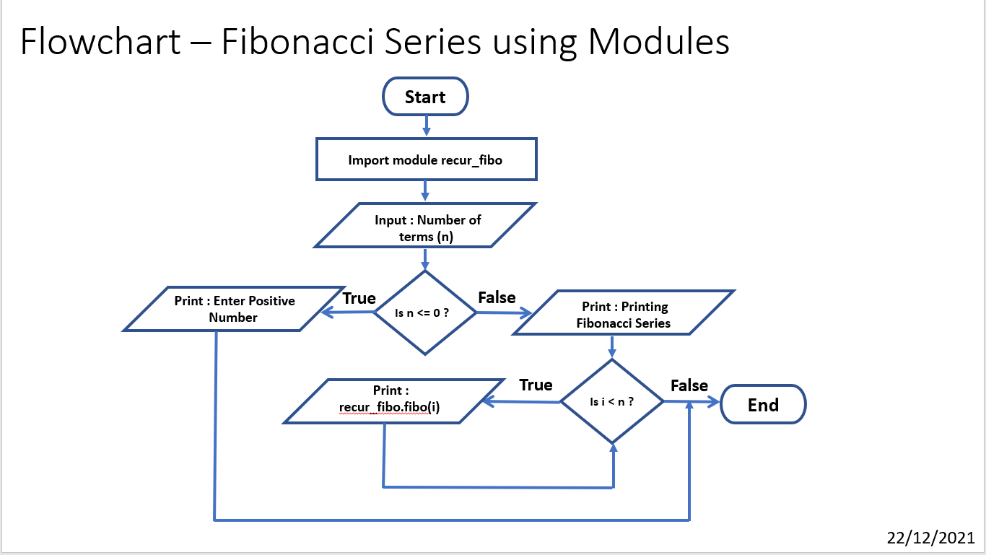

**Algorithm:**

1. Initialise the program
2. Import created module “**recur_fibo**”
3. Input the number of terms to be printed and assign it to “**n**”
4. Check if n <=0, if true, Print: “Enter Positive Number” and end the program
5. Else, Print “Printing Fibonacci Series”
6. Create for loop which iterates the value of “**i**” till “**n**”
7. For each iteration, print the output of “**recur_fibo.fibo(i)**”
8. End the program

**Source Code:**

import recur_fibo

n = int(input("Enter number of terms: "))

if n <= 0:

print("Plese enter a positive integer")

else:

print("Printing Fibonacci Series:")

for i in range(n):

print(recur_fibo.fibo(i))

**imported module: (recur_fibo.py)**

def fibo(n):

if n <= 1:

return n

else:

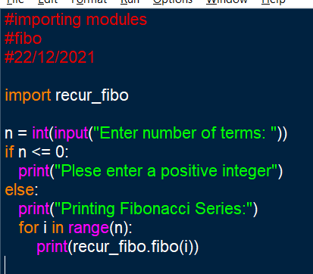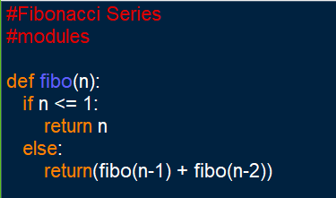 return(fibo(n-1) + fibo(n-2))

**Output Screenshots:**

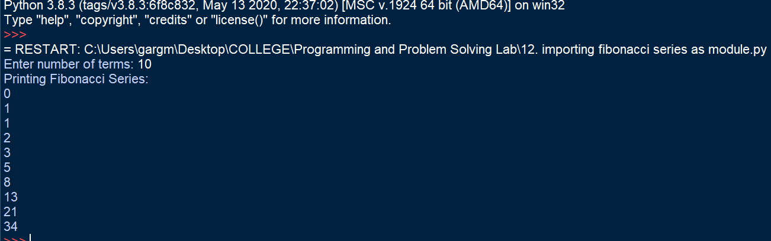

**Learning Outcome:**

The following program helped in understanding the use of functions and modules. It helped to understand how to define and import modules to make programs simpler.

The program also helped to understand the utility of modules in long programs. It helped to understand and deploy modules and functions.